**Lab #2 Report: Initial Virtual Machines**

**CSC432 – Computer & Network Security**

**Franklin Nuth**

**30 January 2019**

**Abstract** In this lab, I will be configuring the virtual Linux router and the virtual Kali Linux that are provided to me in the ProxMox Virtual Environment. I will use the command window in the Cent OS 7 Linux router to configure two network interfaces of the router, allow IP forwarding, add masquerading to the two interfaces, and add a firewall in between for added security. I will also configure the Kali Linux virtual machine so that it connects to both the virtual router and the internet.

**Introduction** Initially, I begun this lab with no idea on how to use the command prompt in the Linux operating system. Fortunately, I still have the notes from the Introduction to Networking notes form my sophomore year, which is a prerequisite for this course. It will be an interesting experience to see the theories I learned long ago being applied in a hands-on lab.

**Processes & Screenshots** The first thing I had to do was learn how to save and exit files in the Linux operating system. I learned how to shift between Insert (I), Replace (R), and Command Mode while coding the router’s files (pressing Esc key during Insert or Replace mode). In order to save a file, I have to enter (:w) during Esc mode, and I have to enter (:q!) during Esc mode if I want to exit the file and save any changes. The first order of business was that I had to create and configure the first network interface named ens18. I substituted the capitalized words in the lab with my actual information.

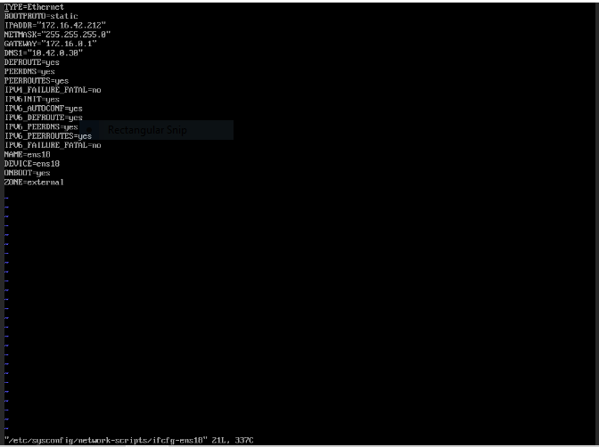

***(My configuration of the interface named ens18.)***

I have followed the above process again, except this time I’m creating an interface called ens19, with some slight changes in the information.

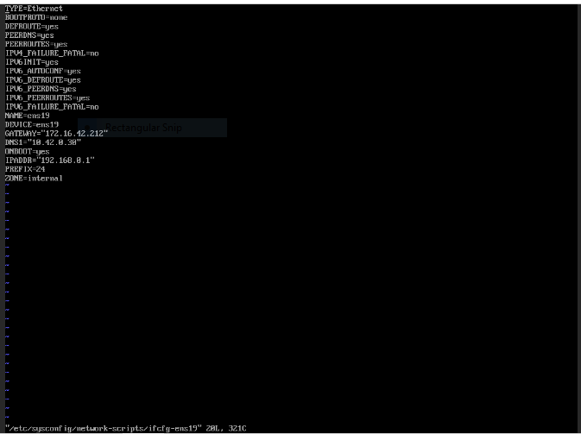

***(My configuration of ens19.)***

After restarting the networking service, I then move on to configuring the service so that it will support Network Address Translation. I created a file called ‘/etc/sysctl.d/ip_forward.conf’, which I will soon use to activate IP forwarding for the firewall. Fortunately, the code has already been made for me, so I saved my changes and exited the file. Last but not least, I then move on to allow IP masquerading between the two interfaces. ens18 will be the public, while ens19 will be the private interface. After making the appropriate configurations and applying certain commands with ‘firewall-cmd’, I finally got a firewall up and running.

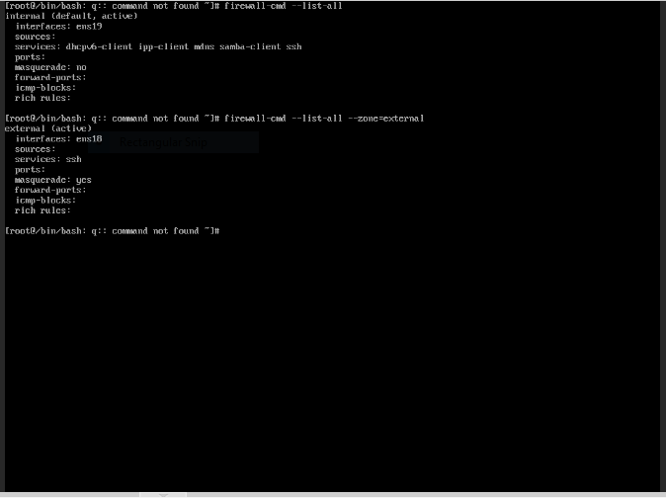

***(My configuration for the firewall.)***

Now my task turns to seeing if my Kali Linux virtual machine is connected to the virtual router and the internet. My job is to connect the two devices together, and draw a network diagram to depict the topology of my virtual network.

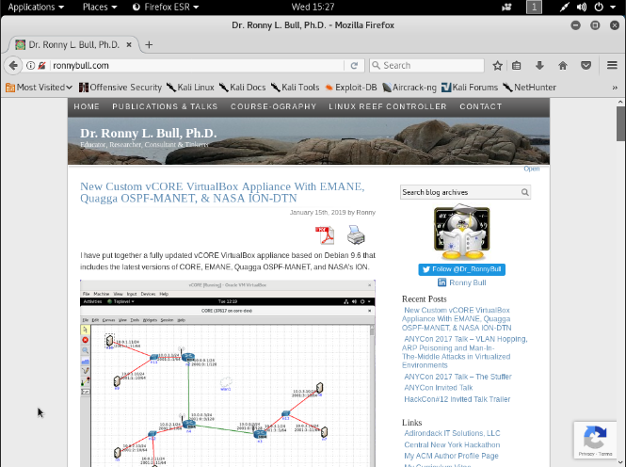

***(Proof that my Kali VM can access the internet.)***

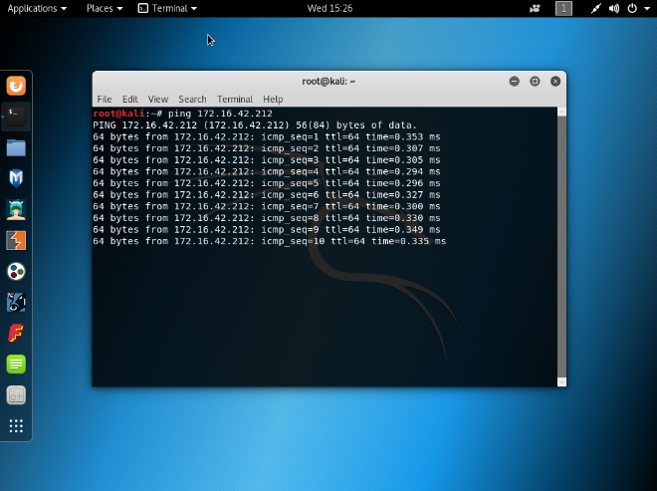

***(Proof that my Kali VM can ping my router system, whose IP is 172.16.42.212)***

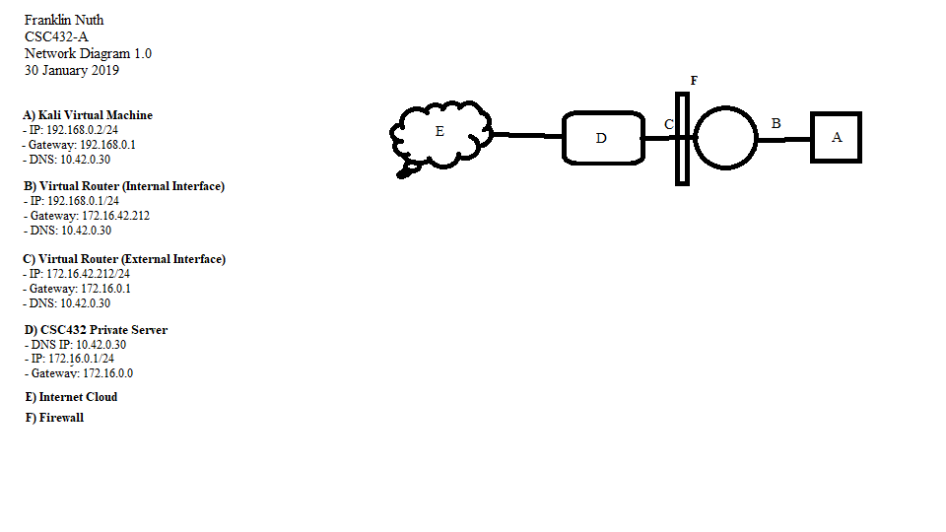

***(A picture of my network diagram.)***

**Issues & Resolutions** As expected, I ran into a lot of issues due to Linux’s command line being a new concept to me. My first issue was trying to understand how to save and exit files in Linux. The commands were trivial, but I sifted through many online articles to discover what syntax was proper for my version of Linux. I also consulted a website called [www.openvim.com](http://www.openvim.com), which helped me a lot in learning how to use the common commands in Linux. It consumed a lot of time on my end, but it was gratifying for me to learn those two basic Linux skills so I can do the lab. Another issue I experience is that even though I have a wired connection, my Kali virtual machine is not able to ping my router or the internet. What I did wrong is that I wrongly configured my private net ID for the firewall. In one part of the instructions when I was creating a firewall rule for IP masquerading, I misunderstood the concept of a private net ID and typed ‘fsnuth/24’, when I should’ve typed my private IP address which is ‘192.168.0.1/24.’ I thought that a private net ID means a private username, so that’s why that mistake happened. My final issue was actually activating the connections from the router to my Kali VM. I never knew that I could type ‘nmtui’ into the router’s command line and activate a network connection that way. Even though I made the connections active from my Kali, I couldn’t ping 8.8.8.8 until I activated the connections from the routers.

**Conclusion** I started out his lab somewhat equipped with knowledge from my previous course, but not on how to use the Linux command line. The lab taught me how to save and exit files in Linux, configure interfaces for the network, how to allow IP forwarding to a firewall, and masquerading. I also learned how to test the connectivity between a Kali operating system and a router. This lab made me got my feet wet in the Linux world, and I aim to practice as much as I can so that I may swim with ease.

**References**

Kili, Aaron. 2017 May 20. *How to Save a File in Vi / Vim Editor in Linux.* Retrieved from: https://www.tecmint.com/save-file-in-vi-vim-editor-in-linux/